Splash Screen
Workshop #02
Flutter Developer Bootcamp

Purpose
This workshop demonstrates how to Create A Splash Screen.

Problem
In the workshop, make a splash screen. It should last 3 seconds and have a blue background. The splash should show a Flutter picture or icon and some Text.

How to Solve
1. Checkout the workshop from Git Repo:
git clone -b <user-branch> <repo-URL>
2. Open the root folder inside VS Code
3. To build the app click the run option in the main method { }
4. Create a splash screen with flutter icon or image
5. The background colour must be blue.

You Will Achieve
At the completion of the workshop, you will study how to set up a splash screen with a timer.

Screenshots

Before implementation (without Splash Screen)
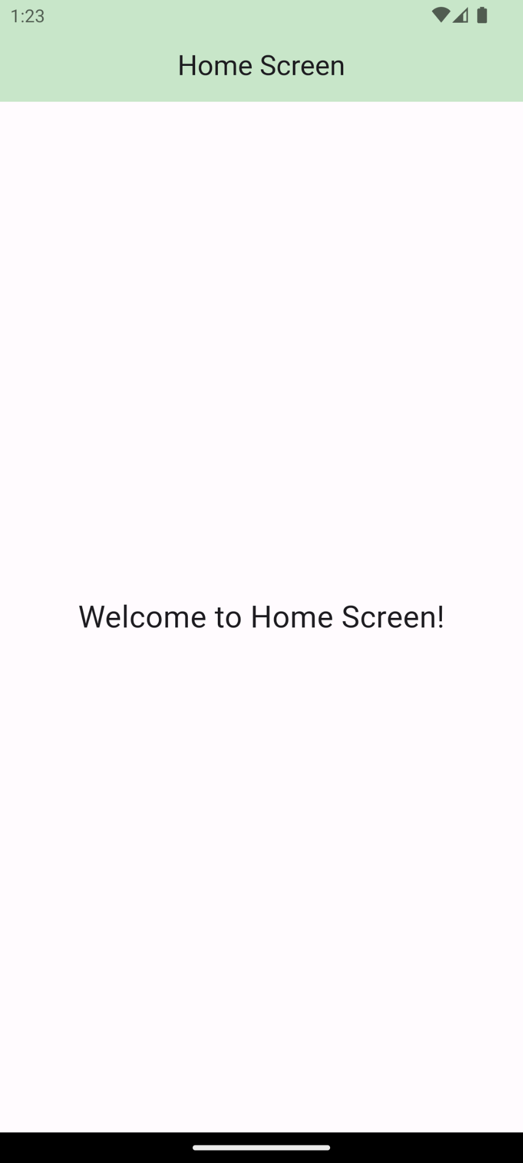

After implementation (With Splash Screen)
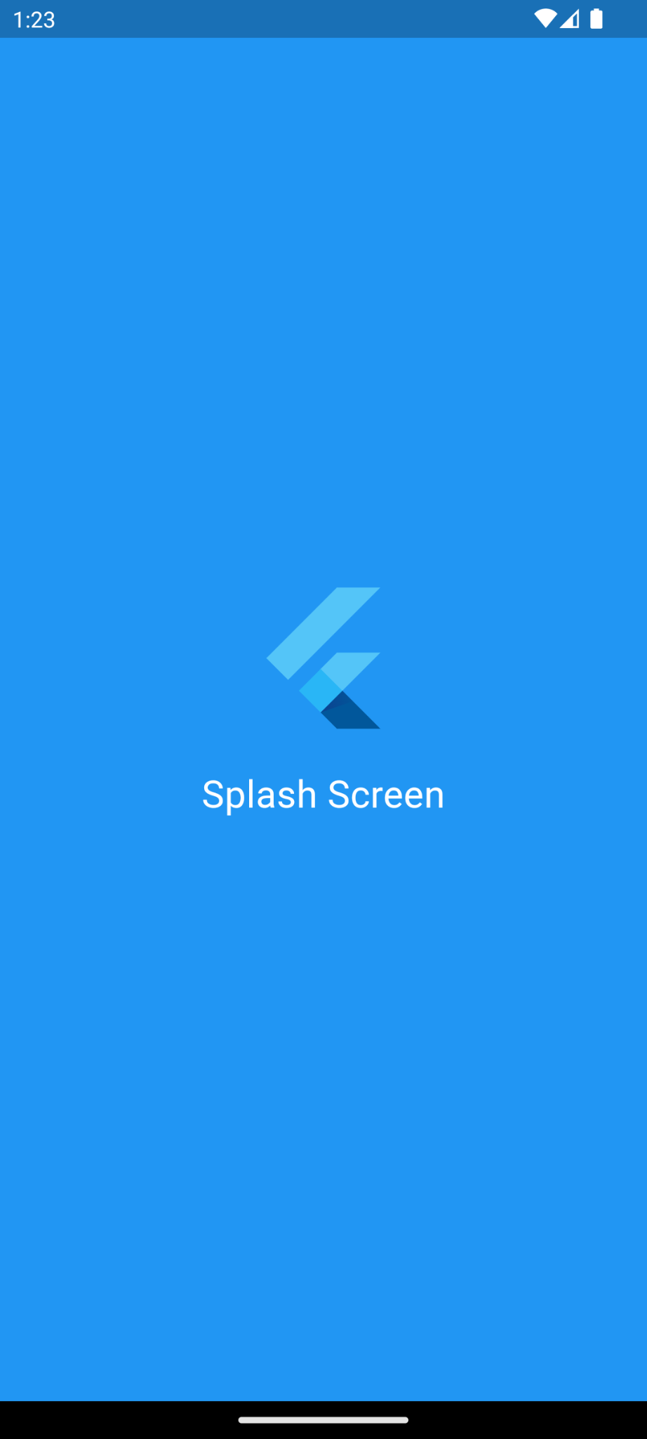

How to submit your workshop
Push your project back to the same git branch using command:
<command name>

Happy Coding!

